**G.Harish**

**192011095**

**USING RAPTOR – AMSTRONG NUMBER OR NOT**

**LOWCHART**

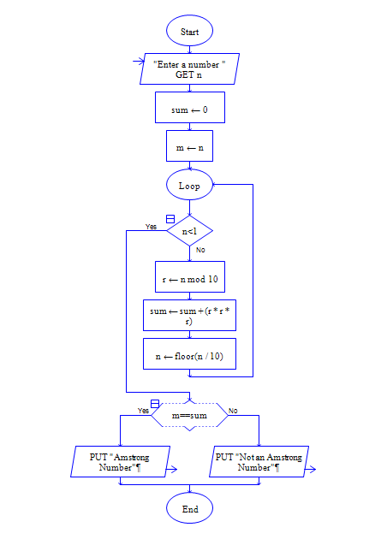

**INPUT**

371

**OUTPUT**

